‘Be everywhere, where you cannot be!’
by
Krisztina Bence
01/05/2012
Contents
1. Why will we always travel? 4
2. Personal experience – do not lose it! 6
2.1 IT devices to be expected 6
2.2 The use of advanced technology in touristic fairs 8
2.3 Fares and rules of the high-quality system 9
3. ‘Be everywhere, where you cannot be!’ 11
3.1 The robot-era will start? 11
3.2 How can this complicated system be effective? 13
4. The time of renewable natural resources 15
5. Why is this future likely? 16
6. References 17
7. Appendices 18
Appendix # 1 18
Appendix # 2 19

2020. Far, or not – just a question of point of view. What is sure is that innovations will not stop now. Every day new and new technological developments hit the media; and how much we keep up with them is just a matter of attitude – and budget of course. Technical facilities will soon overrule personal contacts, and a highly digitalized world will be built up in the metropolises of the 21st century; where everything can be organized by a few clicks, and computers are the primary medium of communication and social life.
As trends are developing nowadays, this vision seems more than likely in the eye of politicians, journalists, scientists and the people of the street. Some regard this phenomenon as a serious threat, while others think it is a natural path of human development, which is necessary – but since both viewpoints have some reality in them, it is impossible to decide, which is the ‘truth’ in this sense. And it does not change some things anyway.
People will always want to travel! The power of personal experiences will never fade away, and a computer can never replace what we have seen, felt and lived through. In a world, which is being digitalized to a high extent the number of experiences is declining: we do not get into funny or troublesome incidents, do not meet random people in random situations and we are not affected by that big amount of various stimuli – which should be a basic need of human beings. Travelling can offset the monotony of everyday life and put people into situations different from the ones they got used to, challenge them and amuse them – some things that should never be lost.

1. Why will we always travel?
Travelling is something that has always belonged to the lives of human beings, based on their nature and basic needs. In order to examine the motives for travelling, the easier way is to take the well-known pyramid of Maslow as a basis (Picture # 1). We know that first of all the basic needs have to be fulfilled in order to be able to step to the next level. Since travelling can be motivated by several emotional factors, the reasons for travelling can even be found on the third step of the Maslow Pyramid; belonging and social needs. Many scientists even say that this is one of the main motives for travelling: after one’s basic personal needs of physiological and security manner are met, he or she can turn to the needs of higher level, such as those of cultural and emotional manner. On this level the motivation for travelling arises from the social trends of different cultures, which have been present in human life since the beginning of development of culture. After the basic needs of the cavemen have been fulfilled, they turned to the satisfaction of their higher level needs – and soon this has lead to the trend of holiday-making, which was so popular in the Roman Empire (Ivanovic; 2008).
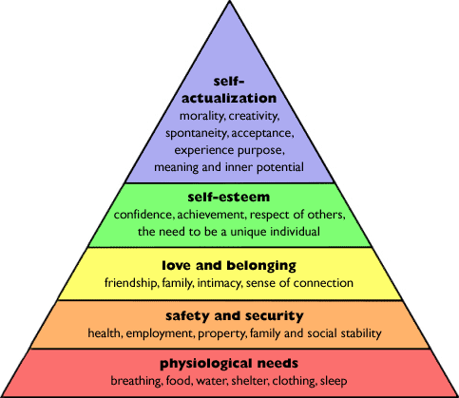
Picture # 1 – Maslow’s Pyramid – hierarchy of needs (Source: http://thefragranceofshootingstars.blogspot.com)

But the motivation for travelling can result from a higher level need as well: self-esteem and self-actualization are the main drivers of nowadays adventure and experience-seeking young individuals. If we consider this, our attention will be raised by an important fact: as cultures develop so do the demand and requirements for travelling. While centuries ago it was enough to just travel a few kilometers away, or visit the seaside, nowadays the demand for adventurous, experience-providing and even risky trips.
If the trends keep on by the current pattern, by the time of 2020 travel agencies have to come up with some really innovative ideas in order to fulfill different requirements of the young adventure seekers. And this leads us to the question of tourism fairs: in order to attract the customers for the travel agencies, the first step is to create an efficient promoting campaign, which engages those, who seek for something special.

2. Personal experience – do not lose it!
The more digitalized and impersonal our world will be, the more the need will be for facilitating personal connections. As more people realize the threats of diverging from each other (feeling their needs for social relations and belonging in danger (Picture # 1)), they will seek for opportunities to get acquainted with others, to be social, to live again. This is why fairs will never lose their real role of collecting people of shared interests to the same spot at the same time.
Therefore anyhow developed technologies will be, the crew of the fairs will always remain human, aiming to emphasize the social beings we are. They will be there to provide information and help; and to serve the participants of the fair, who are going to have pretty high expectations towards the organizers by that time.

2.1 IT devices to be expected
Though personal relations are enhanced, in 2020 the core of the fairs of the future will be highly dependent on the achievements of information technology. In order to get more acquainted with the technological advances to be expected, I asked Miklós Bence, chartered electrical engineer of Budapest University of Techology and Economics (Appendix # 1). Since currently he is working in the field of information technologies I have got a huge amount of inevitable information regarding the future trends of IT development.
During the interview he told me that as technologies are developing right now, the quickest advances are to be achieved in the field of 3D displays. 3D televisions are already produced, also for home use, and several cinemas are using high-quality 3D technologies as well. Based on this we can assume that these technologies are due to achieve lower production costs; therefore they can soon become the part of people’s everyday life.
Knowing this it is reasonable to expect that just like other segments, fairs – and especially tourism fairs – will highly build their attractiveness on the facilities of amusing people with three-dimensional displays.
What more, the industry of advertisements and movies with smell-effects is also becoming stronger and stronger. Although the idea is not new – there have been attempts already in the 1980s to provide people in the cinema with more than just a simple movie with visual effects; but as my interviewee expressed, advances have been achieved, and more are due in the near future regarding this technology as well. The devices for producing different odors both in closed rooms and free space are developing, so if the trend is keeping on like this, we can expect the aroma-movie industry to boost in the future as well.
When I asked about the advances due in the field of telecommunication, especially video-communication, I got answers – backed up by some recent articles - , that can be pretty surprising for nowadays’ people – but which could mean the future as well. In these days micro-helicopters – so-called drones – are developed, which can receive radio signs up to the height of 50 kilometers above the surface. These GPS-operated drones are planned to be used by Pirate Bay torrent site – the idea was inspired by the recent actions of authorities against their servers (Index; 2012).
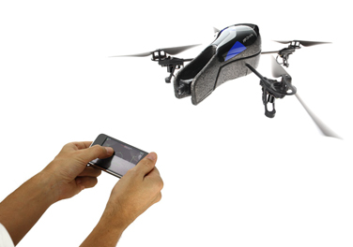
Picture # 2 – A drone, which looks like a bird (Source: www.24-7pressrelease.com )

The same kind of drones are also developed – and even used for some basic tasks – by the US and other armies as well in their everyday life. The drones can fly varying distances – currently this depends on the size and fueling of the micro-helicopters – and may be equipped with cameras in order to record the route of the device and to gain picture data from places that humans might not be able to reach. The only disadvantage of these drones is the low battery life, when we are applying small – and of course more silent – devices; however, improvements are to be expected in the near future, and the drones will be able to fly even long distances with the increased battery life (Index; 2012).

2.2 The use of advanced technology in touristic fairs
Seeing how quickly both the 3D technologies and the drone industries are developing, it is not an exaggeration to assume that soon these technologies will become the main driving forces of fair-development. In the case of touristic fairs a combination of these two important resources can be used in order to delight the customers with increasing demand.
In tourism drones with high-enough battery life can be used in order to provide potential travelers the opportunity to see their destination and check, whether the conditions are identical with those offered. Providing always a live picture of the destinations, the hotels, restaurants and other places the touristic agency has a contract with would decrease the risk taken by the purchasers of tours and tour packages. Drones may fly through some pre-determined routes, of which the customer can choose which to take; always providing a 360° panorama picture of the place for the viewers. These pre-determined conditions are needed in order to prevent the misuse and abuse of these valuable devices – and of course to protect the visiting of sites which would be dangerous, unethical or prohibited – such as military centers, state buildings, private spaces.
The pictures of the different drones could be watched in small so-called ‘3D rooms’, where – with the help of 3D glasses – customers can ‘walk around’ on the spot they have chosen. With the help of improved technologies different odors could also be provided for the person being in the small, round-shaped room; to enhance the feeling of being on holiday by the fresh smell of the sea, the heavy aroma of a flowery field or a fruit-garden or the typical odor of the streets after a refreshing rain. According to surveys these features can more strongly stimulate human behavior than just single images and sounds, so the positive responses given are expected to be higher (bumm.sk; 2008).
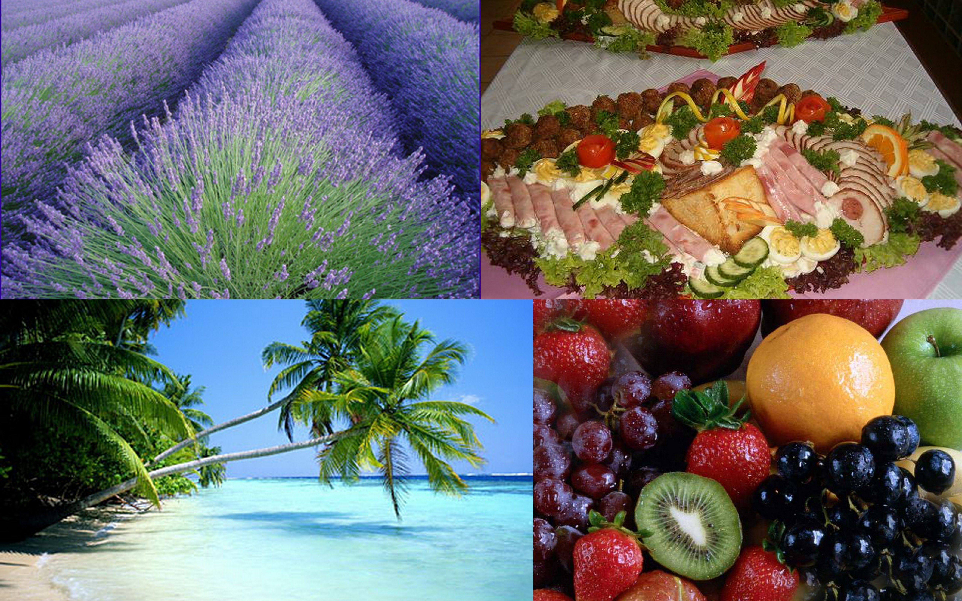
Picture # 3 – The power of smells (Source: google.com)

Since one does not actually have to walk in order to ‘walk through’ the destination; this method is also in favor of disabled people for whom it is difficult or impossible to stand on their feet – they can also experience the tours, just like a person without any handicaps. In the ‘3D rooms’ a chair turning in 360° can be provided for those, who would rather sit while seeing the place where they would like to travel, but these furniture can be removed and replaced by a wheelchair if necessary.

2.3 Fares and rules of the high-quality system
Of course the facility of ‘going around’ touristic destinations does not seek to provide an opportunity of 3D television watching, and prevent people from actually travelling to the spot. Therefore primarily the checking of hotels and service providers would be emphasized primarily – with a live picture, with an aim of avoiding misleading customers by offers superior to reality – and the best-known tourist attractions, such as Eiffel-tower, Big Ben, Statue of Liberty, Taj Mahal etc. would not become a part of the virtual tours.
Beyond this a time limit would be set for the tours made on the fair; to maintain curiosity and make people want to travel to the place after seeing parts of it.
Since the costs of providing such a high-quality event full of highly modern technical equipment it is expectable that the prices of attending a touristic fare will reach a higher level as well. The current price of approximately 1500-2000 HUF (5-6€; taking the Touristic Fair of Hungexpo, the biggest fair organizer of Hungary; fair of 2012 in Budapest as a base point) will not be sustainable under these new circumstances.
However, by the increased price organizers will ensure the opportunity for all participants to visit the offered programs of the companies and destinations chosen. Tickets for the occasion should be purchased in advance in order to prevent the venue from being overcrowded; and participants are required to sign up for the ‘virtual tours’ they are intending to take.
Since each agency represented on the fair will operate with their own virtual-tour-cabins – the number of which can be purchased by the companies, just like exhibition space nowadays – it is up to the companies whether they would like to maintain always a free cabin for the additional people dropping in, who choose to visit more tours than applied for, or they focus only on the subscribed customers.
Fixed price estimations can not be given for the attendance, since it is dependent on several factors including inflation, prices of devices and energy and the prices set by exhibition-organizers for the participation and space requirements.

3. ‘Be everywhere, where you cannot be!’
This could be the slogan of the digital part of touristic fairs of 2020. Even if people would like to enhance social relations and personal presence; limitations of distance and time can be strong binding factors, preventing people from taking part in these events. Also environmental issues could be raised against travelling to the place of a fair, therefore online presence should be made possible too, in order to attract more people from diverse locations – and even make the fair international.
The target group of this possibility is primarily not everyday people, rather businessmen interested in the fair, but not being able to be present there – either from the side of tourist agencies or visitors.
Since nowadays it is already possible to take part in video-conferences, via Skype for example, the main factor for being present in the fair is already given, existing and even popular. By the usage of Skype or other devices suitable for video-communication it is possible to let people from distant locations be present on the fair as well. But how can they attend the event and move there?

3.1 The robot-era will start?
According to Miklós Bence it is possible that soon enough the use of robots will be more popular, not only in medical and research & development and military segments; they can soon appear in households and everyday life as well. There are increasing number of intelligent household-robots, which can even sense and to things without any special command, as he said.
With respect to the data existing we can expect robots to become part of several fields of life – and they may be present in the case of touristic fairs as well. For people, who cannot be present personally on the fair, the organizer can provide an opportunity of attending the event via internet connection from any point of the world – and robots will make it possible to do so. Small, round, barrel shaped robots of approximately 1 meter height can move around the venue, showing the distant attendants everything they would like to see.
Roll-L (Appendix # 2), the barrel shaped small robot, rolling around on small wheels will have a hemisphere shaped, breakage resisting glass-head, in which a small camera takes place, that broadcasts the things happening on the fair to the attendants sitting in front of their computers. His round, barrel shape is optimal, because this way he can resist the probable effects of the human visitors of the fair – it is hard to knock him off due to the massive shape, and his steel-body and breakage resisting head will protect him from the possible injuries. The body of Roll-L will be equipped with a screen - directly below the glass-head -, and a loudspeaker, so that the people, who are present on the fair only online, will still be able to communicate and negotiate with those, who are physically present.
The idea of enhancing communication via the Roll-L robots relies on the system of Skype video-conversations. Since the screen is approximately in the height of a person sitting comfortably on a normal-sized chair, business-negotiations are facilitated among those who are present and far away. The body of Roll-L contains a keyboard as well, if the participants prefer written communication; and it will be even possible to print small notes, business information or terms of an agreement in basic black-and-white format with the help of these small creatures – just like cashiers do.
Below Roll-L’s screen there will be an ‘identity card display’, where the online-attendants may disclose personal (age, sex, interests), business (occupation, place of work, business profile) and contact (e-mail, phone, fax, Skype) information if they choose to do so. Disclosing personal information is optional, people can keep anonymous as well, if they prefer to.
The usage of Roll-L robots can be bought by buying an ‘online ticket’ for the fair in advance for pre-determined time interval. One will be able to choose between options, such as specific tours of one area or another, an overall trip around the fair, or an optional tour, where the customer can pick the destinations they would like to see. These options will be present in the ‘mind’ of each Roll-L pre-programmed, just like all the exhibitors of the fair and their exact location and portfolio of services.
The small Roll-Ls move through the fair, showing their temporary owner around; and if a customer chooses to enter one 3D room, the Roll-L can stop. Attendance of 3D services will be available from home as well, since – as Miklós indicated – the three-dimensional displays and screens are undergoing a rapid developmental phase; it will be possible to watch things in 3D on personal computers as well.
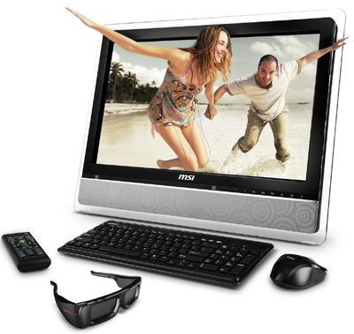
Picture # 4 – The time when figures will step out from the computer (Source: www.msi.com )

3.2 How can this complicated system be effective?
Since one touristic agency can have more drones flying around one touristic destination, they can always maintain one for online customers, therefore they do not have to wait for the customers personally attending the 3D rooms. This can prevent agencies from being overloaded – the online and personal attendance should be operated separately from each other.
In order to operate the system of Roll-L robots safely and protect them from hacking, the attendance by one Roll-L has to be booked in advance for a predetermined time period. When the time required is paid by the customer, he or she will get an access code for the system, which will be deactivated after the given period of time and cannot be used ever again. If the customer wishes to spend more time on the fair, they can – of course – lengthen the time of their stay during the visit as well – in this case their access code is going to remain valid for an additional period of time.
The number of Roll-L robots hired and/or used on a fair can be determined by taking the number of customers applied for the fair in advance into account; but certainly the organizer should have some spare-robots as well, who might be able to replace their colleagues in cases of customer overload or technical failures.

4. The time of renewable natural resources
Our rapidly developing world is running out of non-renewable natural resources, and the problems of environmental pollution are getting more than crucial, as the time goes on. Soon each and every sector of industry should start to think about alternative ways of fulfilling their energy needs in the long run. This industrial sector is getting more and more emphatic in several countries, and experiments and developments are already going on using solar, wind and water-energy for instance – numerous areas are already highly dependent on these sources of energy (www.nonrenewableresources.org).
Since the social events provide a good opportunity for forming behavior, fairs are a good medium of enhancing environmentally-friendliness; therefore organizers have to be conscious about what kind of resources to use. Dependent on the location of the fair, various resources might be used and combined, in order to reach the most efficient and environmentally friendly point. In the case of hosts with high number of sunny hours per day a good solution would be to apply solar cells – even Roll-L robots might also apply solar energy as an alternative for electricity. Just like solar energy, the power of wind can also be used widespread, thanks to environmental conditions.
Since Roll-Ls move a lot around the fair during the day, the power generated by their wheels (six or eight wheels per robot would provide safety and stability for a moving robot suitably) could be also used by the small creatures in order to save energy. This can be an efficient way of recycling energy, and it can also make Roll-Ls more independent from resource supplies and energy prices.
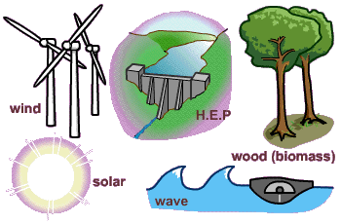
Picture # 5 – Renewable resources, which can mean the future (Source: waterburyleap.org)

5. Why is this future likely?
Taking the current developments of technologies and estimations of future trends into account, this is a likely scenario of the future. Of course other scenarios might have similar possibilities to happen - based on the current state of nature - and this is only one of the possible future events; but based on my analysis of the present situation and various sources of future estimations this seems to be a possible way to continue.
Since the basic human needs have remained constant over long years of history, this does not seem to be a basis for drastic changes. Although the path, where technological inventions are heading is a great deal vaguer, the trends of development are possible to be estimated more or less punctually.
Current visions of the future however also depend on people, their attitude of life and changes; and of course expectations as well, therefore some visions can be extremely different when considering the ideas of different people – but this is what makes future and life so interesting and diverse.

6. References
Bumm.sk (2008) Bejött az illatos mozi http://www.bumm.sk/21046/bejott-az-illatos-mozi.html (Retrieved 27th April 2012)
Ivanovic, Milena (2008) – Cultural Tourism
Index (2012) Levegőbe költözne a Pirate Bay http://index.hu/tech/2012/03/19/levegobe_koltozne_a_pirate_bay/ (Retrieved 26th April 2012)
Index (2012) Gesztusokkal vezérelnék a drónokat http://index.hu/tech/2012/03/19/gesztusokkal_vezerelnek_a_dronokat/ (Retrieved 26th April 2012)
MTI (2007) Illatos filmvetítések http://www.stop.hu/eletmod/illatos-filmvetitesek/226607/#null (Retrieved 27th April 2012)
Non Renewable Resources http://www.nonrenewableresources.org (Retrieved 29th April 2012)

7. Appendices

Appendix # 1
Question sheet
Regarding the technological advances expected by 2020

- What are the most important IT devices being developed at the moment?
- How much do you think we can expect from these in the near future?
- Where do you think the world of information technology will stand by the time of 2020?
- What developments can we expect regarding screens and 3-dimensional displays?
- What are the most important achievements of telecommunication right now, and where are we heading?
- How much could the area of video-communication move further?
- What do we know about the existing robot-technologies? Are they applicable at the moment?
- How cost efficient are they right now regarding battery and fueling?
- Where is this area heading?

Appendix # 2
