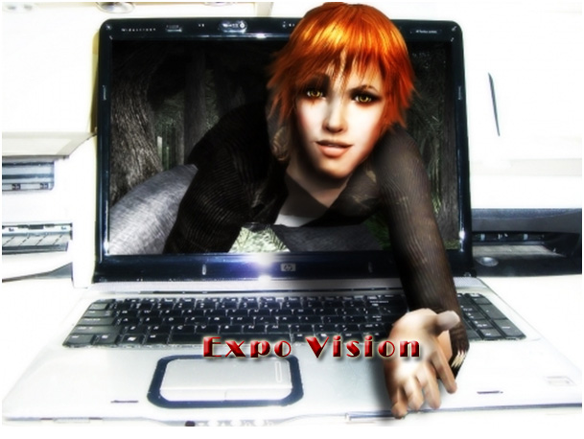

Made by:
Team Academy II. grade
University of Debrecen

2012. Debrecen

Index

Introduction 3
1. SWOT analysis 5
2. Social and economic prediction 7
3. Our expo program 11
3.1. Interactivity 13
3.2. Technology 15
3.3. New experience 16
3.4. Environmental protection 18
4. Financial part 19
4.1. Expenses 19
4.2. Incomes 19
Summary 20

Introduction

Our team consists of enthusiastic Team Academy students. Our aim is to develop new and innovative business opportunities for Hungarian enterprises. In the competition we would like to present how we imagined an expo would look like in the future. The topic we have chosen is the following: According to the information and opinions of visitors and exhibitors how exhibitions and fairs will be changed and what is the vision of them by 2020 (how they will look like, what kind of social, economic and cultural roles they will have).

The digital revolution which was gone off in the last 2 decades has changed our communication and buying habits dramatically. At the beginning of the second decade of the 21st century community websites and webshops were spread which caused changes in buying habits and social interactions. Not only the mentioned parts has been changed by the development of the internet but the habits of reading, listening to music, watching TV, getting information have also been varied. The penetration of smart devices in the market let us keep in touch with the world anytime we want by pushing a button.
The digital revolution increases. According to the latest survey in Europe and the United States 6 people out of 10 have smart phone and access to the internet. Thanks to the new internet applications, blogs that formerly worked separately now work together. In the last two years the number of Twitter users has increased by 1200% and according to the expectations by the middle of 2012 there will have been more than 1 billion Facebook users. The formerly independent webshops are fading into the community websites creating complex web pages on which users can keep in touch with each other, listen to music, watch videos or reach any part of the world. The opportunities that are offered by the internet disperse faster and faster. According to the research institutions the number of the users of community websites will be 3 times more by 2020.
As the internet conquers the whole world traditional business units are rolled back so exhibitions and expos are desolated. Despite of the rapid development passing off in the world, which changes the buying and the habits of getting information year by year, exhibitions have not been able to keep up with the changes yet. There are many customers who would rather get information from the internet, which provides anything they want by pushing a button, than visit an expo.
At the pages below we show what kind of opportunities we have in order to introduce virtual expos to the next decade and how they will be able to attract the mass of customers to a new area by using the benefits of community sites and webshops. We present in short how we imagined the next generation of expos would look like and we show what kind of devices and opportunities there are to give a buzz and make the expos popular for the customers.

SWOT analysis

On behalf of being able to introduce real innovations to the market we have made SWOT analysis furthermore our strategy is also based on it.

1. chart SWOT analysis
Strengths  - high standard  - spectacular appearance  - varied programs, winning-games  - interactivity  - different kind of services for exhibitors  - aimed public  - marketing devices  - mobility | Weaknesses  - high initial costs and entrance fees  - the number of exhibitors and visitors is hard to be calculated  - it is hard to measure the efficiency of exhibitions and fairs  - entertainment and professionalism can be merged easily  - little marketing
Opportunities  - companies with similar profile can get to know each other  - Hungary becomes more popular for foreign exhibitors  - development in information technology  - technological development  - development of marketing communications devices  - environment protection  - lower expenses | Dangers  - big competition among organizers  - people can be uninterested and unmotivated in expos  - business people have little free time  - language barriers

Strengths – Opportunities strategy:
- Whereas exhibitions and fairs are for aimed public so the profile of the companies that take part in the expos is similar than the exhibitors’. In this way not only the public can choose from companies with similar profile but companies can get to know each other.
- The Hungarian exhibitions are well organized and this high standard must be very attractive for foreign exhibitors.
- Thanks to the technological development it is getting easier to make exhibitions or fairs more interactive for example letting the visitors create the presentations as they want by using interactive tables.
- As a result of the technological development very spectacular expos can be organized.
- Marketing expenditures can be decreased by choosing aimed public.
- If the promotional products are made from environment-friendly materials it contributes to support the environment protection.

Strengths – Dangers strategy
- In order to be up to the competitors the standard of the expos has to increase.
- To avoid people becoming uninterested there should be colorful programs and winning-games.
- Because of the high standard, language barriers have to be avoided by for example applying simultaneous translation or using international language.

Weakness – Opportunities strategy:
- Decreasing high initial costs by exploiting the development of information technology.
- Exploiting the development of the marketing communication devices (e.g. Facebook) in order to be able to advertise expos more widely.
- Utilizing the development of the informatics systems to trace the buying habits of the buyers of exhibitors (e.g. online buying). So the productivity of expos can be measurable in this way.
- Thanks to the development of the information technology business men who have not had time for taking part in expos now they would have.

Weakness – Danger strategy:
- By decreasing the entrance fee, lack of interest can be avoided and more mass can be encouraged to join.
- lack of interest cannot be formed because of professionalism and entertainment have been merged.
- Being updated is really important in order to keep up with the concurrency.

Social and economic prediction

At the beginning of the 21st century internet gained bigger ground than we had ever thought. By today the development of information technology has a really big impact on people’s life for example it is not surprising if people ‘speak themselves’ on the street or during driving a car. Nowadays if anything happens in the world it will be known in a minute.
In our days not only the expansion of the internet but the IT devices and applications (smart phones, Skype, Facebook, Android) make relevant changes in life.
New communication channels have opened, distance among people has disappeared and we have chance to get to know other cultures or explore fields we have not explored yet. The effect of the development of information technology is also perceptible in the economy. On the occasion of a business discussion it is not necessary to meet the partner moreover exploiting the technological opportunities we can negotiate with a foreign partner from our office. So we can not only save travelling fees but our time as well.
According to predictions and researches by 2020 there will have been much bigger changes in the world than we can imagine today. In 2020 the spread of the wideband internet and its coverage will be the novelty. The European Union plans to introduce the wideband internet to everywhere till 2020 in order to every citizen can benefit from the access to the wideband internet. But what is the wideband internet used for?
Besides using it among inhabitants and in business areas there are achievable applications (e-learning, e-health) for the governmental and self-governing sphere from which they can benefit from a lot. Difficulty will be caused by the capacity of the network because it can support the usage of these services in a limited way. It is likely that the problem will be solved by 2020 and these services will be achievable for everyone.
Nowadays the most determinative innovations of informational technology are: Facebook, Skype, Android operation system, Google maps, Google Street View. There importance will be more by 2020 and if they were developed or merged into it would result the appearance of new technologies. These innovations may make our life easier and faster. According to the latest statistics there are about 700 million Facebook users so except for China it is the most popular among community websites. Considering the rate of growth the number of Facebook users will reach 1 billion members by the summer 2012. Facebook could get an award of the most popular community website (1st picture) because in last year the number of users has grown by 400 million members and there are only a few countries (Brazil, Japan, China, Korea, Russia, Belarus, Kazakhstan, Latvia, Ukraine, Moldavia and the Netherlands) where not Facebook is the most visited community website. The rate of growth is still unbroken especially in countries where this page is considered as a novelty.
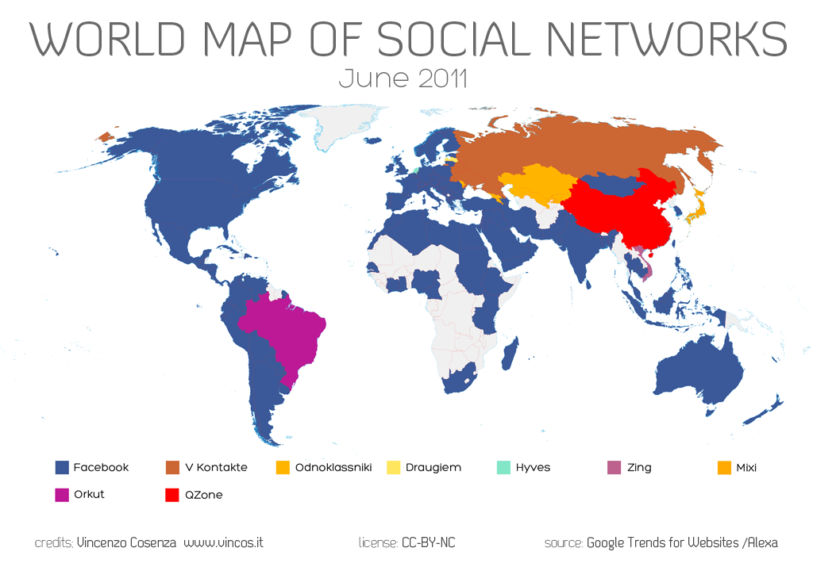
1. picture Facebook in the world

If we wanted to predict the future or just make conclusions we would get the following results: by July 2012 the number of Facebook users will reach 1 billion members which is 14% of the population of the world (so every 7th people would be Facebook user) and the half of the internet users. It is known that browsing Facebook in China is forbidden but if it was allowed the mentioned number could be achieved much earlier.
Besides Facebook, Skype has also gained ground. If our friends or relatives are a member of the community of Skype we can speak with them for free and we can call telephones or mobile phones from any point of the world as well.
Skype may be less spread than Facebook because at first it was for keeping touch with our friends and relatives who are far away. For today this role has changed thanks to the various applications (e.g. video call). Skype is used in business very often especially in international transactions so business men are able to work together effectively or they can keep in touch with their colleagues, clients or partners without taking big distances. They can save time and money moreover it is instrumental in environmental protection.
In February 2012 the number of Skype users achieved 32 million members and we can be sure that it would grow significantly by 2020 because for people it is the easiest way to communicate and save time and money. Anyway it is known that Facebook and Skype cooperate with each other to make our life easier so now we can make video call with our Facebook friends.
In our days among the innovations of information technology the Android operation system is a significant invention. After the millennium mobile phones were spread widely for which many factors contributed to. Because of the competition among providers the price of the devices has become much friendlier which caused growth on demand. On the other hand maintenance costs have also become favourable. The continuous development also contributed to the spread. The latest trend started with introducing smart phones and Android so checking e-mails or browsing on the net by mobile phone are possible now. Besides the telephone industry, there is interest from other parts of the economy in Android especially where high-performance but small displays are used (e.g. board computers, navigation systems etc.).
Google has very good applications for example Google Maps is extremely popular because it is very useful and easy to handle. There is a version which can be programmed for free by downloading a key to meet the requirements. From May 2007 there is another Google application has been available, named Street View which you can ramble on the street of different countries from home with. At present it is available in 30 countries, Hong Kong and Macau. Google is planning to complete this service with a function which you can look around inside buildings with. At first it could be achievable in the USA, Australia, New-Zealand, Japan, United Kingdom and in certain cities of Russia and France.

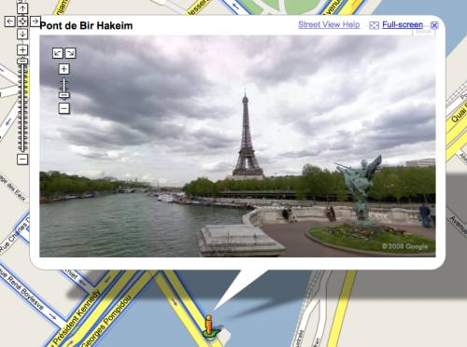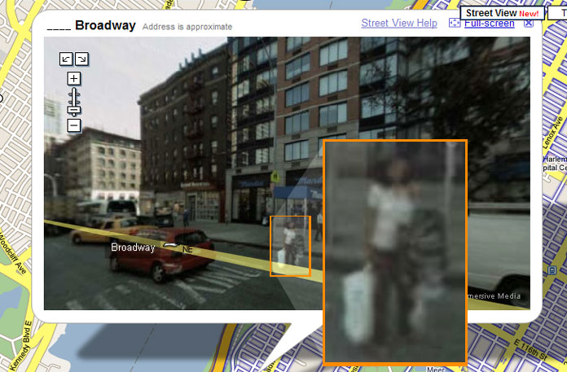
2. picture Google Street View

In our days every technological development and innovation serve people’s comfort and tries to make life easier. Considering the trends by 2020 the time will be the most important factor. Our idea, that is detailed below, for the expos of the future hides opportunities and new perspectives which are beneficial from social, cultural and economic point of view.

Our expo program

Our plan puts the well-known expos and other professional or scientific exhibitions into the electronical world of the 21st century. As it was mentioned earlier, consumption of the digital equipments multiplied to an almost unbelievable extent, and the internet got promoted to primery medium among youngsters. Considering this tendency we are concerned, that expos can be so popular and visited like never before, if organizers utilize the opportunities, given by the internet. Using our idea, organizers would be able to turn back the decreasing tendency of attendance on the expos, and a new period of time would begin in the life of those events which were not able to renew during the past decades.
For the implementation, a ready-made program is needed, which contains all of the necessary tools and graphical elements. Every time an organizer decides to arrange an exhibition, he/she contacts the programmer and tells his/her specific requirements about the event (what size the virtual exhibitory room should be, the exact look of it, how many counters are needed, how long would the organizer make use of the program etc.). Visitors should register on a website and after registration they can buy their entrance tickets in the webshop. While purchasing the ticket, visitors should send a full-size picture about themselves so that the computer will be able to draw up their avatars (virtual character which look will be formed based on the picture). In order to meet the requirements of the visitors, some changes can be accomplished on the character after creation, or they have the opportunity to create a unique avatar or upload a former one. After creating their avatar, visitors can download the program and enter the exhibition. Using this system, visitors can reach all the expos they are interested in, easily, fast and cheaply. Besides, time and inconveniences of travelling, costs of accommodation can be avoided.
When visitors enter the exhibition, the program offers them the opportunity to choose a consultant who briefly informs them about the expo. After this they can select which from the given topics they are interested in and the consultant leads them directly to those counters that they chose. The program starts to download automatically all the information materials that the exhibitor uploaded for the visitors and analysing the visitor’s field of interest it also starts to make proposals which exhibitors’ counters would be worth to see for the visitor.
Participants can walk to any performer or exhibitor and have a conversation with them or the other participants through a microphone, just like in real life. Both the exhibitors and the visitors can hear the people around them but if this disturbs them, they can mute the others at will or start a private conversation with them. In order to make the communication easier, there is a chance to use translating or titling applications. Exhibitors communicate also through computer. Visitors can view electronically uploaded information materials, the website of the exhibitors or even buy something from them immediately using their own debit card.
Realizable advertising surfaces and hostesses with flyers also appear in the virtual room, in the same way as in the case of regular expos, the difference is that in this case, these can be turned off under given conditions. Visitors can enter the expo multiple times or have limited time to spent there for lower price. Organizers can create database from the e-mail addresses and other data of the visitors, of course only with the sanction of them. Identifying the IP-addresses it can be measurable how many of the visitors bought something from the exhibitors. These are only a few examples about the analysis’ that can be made by using this system but limit is the sky.
Expos reachable through internet make the life much easier for people who are interested in such events but cannot afford to travel. This system, which is revolutionary, allows us to enjoy exhibitions or other events in other countries from our armchairs and contains a lot opportunities to improve user’s experience.
There are intelligent equipments such as: Leonar3Do 3D glasses, touch simulating clothes, or the recently invented fragrance printer, which make feeling of virtual reality perfect by connecting them to our PC. With this group of software we are able not only to view an exhibition but also to sense or even smell the virtual world around us. What is more we can have the feeling that the whole event is happening right before our eyes.
Events can be reached through PC and through smart phone, tablet, and smart tv as well. Both the technical background such as the above mentioned smart equipments, and broadband internet are already available. Although these tools have quite high prices yet, considering the development trends, it is absolutely feasible that in 2020 they will be widely available.

Interactivity

Only those products and services can be competitive in the dynamically growing economical and social environment of these days, which can be customized according to the personal requirements of consumers. Features of the service offered by us insure costumers to determine which part of the expo they want to see, who they want to get contact with or what kind of advertising devices they want to meet with.
One of the most important elements of the interactivity is the above mentioned consultant-application, which helps visitors to go on the expo in a targeted way. When the visitor starts to use the program he/she can select the look, voice and style of the consultant, who will introduce topic of the expo and all the exhibitors and puts the map of expo the visitor’s disposal. Consultant tells how many other visitors there are at the given time at the given stand and where are free performers. Virtual expo makes it possible for exhibitors to connect the visitors with their own call-centre if it is needed, although only 1-2 performers are available at the stand. Number of colleagues is also dynamically changeable this way.
In case visitor is interested in it, he/she can ask his/her consultant to give an average introduction about stands and products in order to spare time. Furthermore visitors can ask for information about companies, weather, or anything they need, and they can even setup a compass which allows the consultant to lead them exactly to those stands which they want to see. In case that the stand visitor wants to see in overloaded program makes it possible to setup an observer function which informs him/her if there is a free place. Visitors can connect their microphones with the colleagues in the call-center, so that they can communicate with them immediately when an opportunity presents itself. Consultant can be equipped with a searcher function, visitors this way can search for special subject in the database of the expo and they can put them on the map.
As it was mentioned earlier virtual expo allows us to communicate with other participants, just like in a real expo. The system discerns which avatars are near to us and let us hear their conversations. However, we are able to mute ourselves or others in case that we do not want ourselves to be heard or we are the ones who do not want to hear others’ conversations. It is also possible to tone down or even turn off noises coming from the outer virtual environment. It often happens in a real expo that because of the crowd we can not stand away with our conversation partner to communicate in a quiet and peaceful environment. This system gives a solution for this problem and we can talk in private with someone even in the middle of a crowded place.
Rentable advertising surfaces, flyers or questionnaire activities can show up in a virtual expo as well as in the case of a real expo but in contrast to that, visitors of a virtual expo can turn off or select them. Since a lot of people are disturbed by aggressive advertising this system makes it possible to choose from different options to control this activity. Also we are able to select which products or services we are interested in, thus system will show us ads only about those ones and we can turn off other companies’ ads. Selected companies’ website can be reached immediately.
System has another interactive tool: with language option we can choose between several languages which makes it possible for ads and all the information to be showed in the right language for everybody. In addition to this, a translator application is available for conversations and chat to smooth away all language boundaries.
One the most important elements of interactivity is, that users can edit look of the program. Virtual expo let them create their own look just like in real life, they can change their clothes and accessories, this way they can look however they want to look like.
Options introduced in this chapter show that users can edit the program almost without restriction. They can change practically every function that creates them a virtual reality which can meet all their personal requirements.

Technology

In the 21st century technological devices around us make information flow completely free and with our incredibly fast growing information technology anybody can reach anything. In the age of high-capacity laptops and broadband internet, access to global networks is available for everybody.
Our IT environment is developing so fast, that actually there is nothing to prevent building up the system we created. Writing the necessary programs will not be a problem either since surfaces like those, exist for many years. Programs used for computer games surely will be adapted to virtual expos too for the year 2020. Users also have suitable knowledge about IT background. Additionally, basic configurations for computers nowadays have sufficient efficiency to handle a program like this.
Available IT equipments in these days have a really wide variety including not only PC-s and laptops, but smart phones tablet PC-s etc. also. These devices are equipped with cameras, microphones and several other useful functions. Developers are working hard to create such an operating system which can be used on all from the above listed devices. The first try for this was the so called MeeGo operating system that is compatible with PC-s, tablet PC-s, smart phones, smart TV-s and what is more, with cars’ board computers. Considering this, there is no doubt that for 2020 every equipment will be able to launch the program of a virtual expo.

New experience

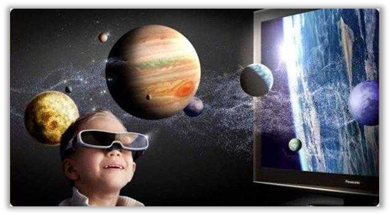
Experience of a virtual expo is so enjoyable and true to nature like never before since we are using 3D displays, crystal-clear monitors and loudspeakers with realistic sounding. In our time already 3D UHD televisions and monitors are available which assure 3D experience without glasses. And the future keeps more in reserve than these well-known and worthily popular products. In the beginning of this century several new hardware were introduced to the market that makes computer experiences more realistic.
3. picture 3D experience

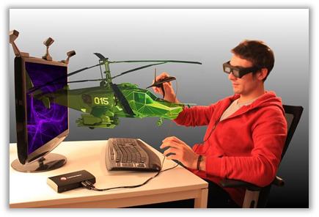
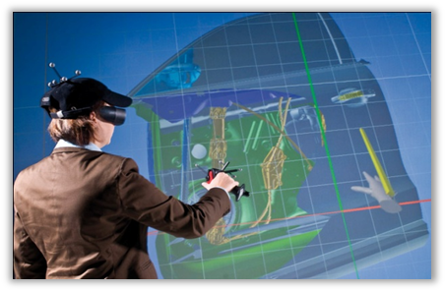
First of these are 3D glasses developed by Leonardo. With these 3D glasses and other tools belonging to them we are able to see and edit two dimension pictures in 3D.
4. picture Leonar3Do 3D glasses

View is particularly essential to users, since eyes are our first and most important organ of sense but inventions nowadays ensure more than just sight. A few years ago a whole new touch perceiving material for clothes was developed in the United States, which connected to a computer is able to perceive our movement and with its small electrodes stimulates skin with gentle electrical activity. This creates a similar feeling like when someone touches us. This material can reproduce feeling of real touch of course only in a limited way, but still it can be one of those products which can spread like wildfire in a few years among users and radically change our notions about virtual experiences.
Another interesting invention is the fragrance printer, a device that makes us possible to create scents at home. This printer works the same way like regular ones but instead of basic colours, it uses basic fragrance samples to create a scent. Next to realistic sight and feeling of touch, now we are able to surround ourselves with pleasant aromas. Let us imagine what it would be like to smell salty odour of the sea in a travelling exhibition next to stand of an exhibitor who are selling seaside holidays. We are concerned that it will be available for almost everybody for 2020.
Certainly there are a lot more developments in process which make our digital journeys even more realistic. For instance devices that perceive speed and direction of our moves, so soon we will can wave the well-known mouse goodbye.
It is impossible to predict what kind of products we will meet in the shops in 2020, but the mentioned equipments are available now. Although their retail price is quite high and only a few people know them, in all probability in the second decade of 21st century they will be more known and affordable for users.
Using these equipments is of course only one option, but virtual expos are great experience also for those who can not afford them.

Environmental protection

Technologies produced by humanity cause serious harm to our environment so we must not leave this out of consideration. It is even more obvious how bad achievements of civilization and technologies affect the Earth. This is why it is important to capture attention to environmental protection.
Science cannot always comprehend fully the functioning of nature so it is often unforeseeable where will an intervention lead. If we want to live on a healthy planet in the future we have to accommodate to the challenges of the environment which we created. For us it is not a problem but for the Earth it is a big problem to regenerate itself.
Every year hundreds of thousands tons hydrocarbon get in the air because of not fully burnt diesel and petrol. Due to incorrect settings of engines and heating equipments and imperfect burning, soot, carbon dioxide, nitrogen oxide, sulphur dioxide and carbon monoxide pollute the air. Thanks to that acid rain is an even more often phenomenon resulting the devastation of several living creatures, trees and old buildings. If the air of big cities is not refreshed by the wind, dust, soot and smoke accumulate near to the ground creating smog, which is very damaging for the health of people.
Condition of Earth will deteriorate further for 2020, but by organizing virtual expos we are able to decrease the extent of this damage. On the occasion of an expo hundreds or thousands of people are in the same place, and although some of us think that this is not harmful, noise pollution is still a noxious phenomenon both for body and soul. Researches prove that it causes stress, hypertension, heart and vascular system disorders and what is more dyslexia. According to some research results environmental noises influence social behaviour in a bad way, since it makes communication more difficult and people get irritated. Furthermore it is also proved that helpfulness of people decreases proportionally with the intensity of noise pollution.
Seeing that our expo is not tied to locality, and it is enjoyable from home we do not have to count with the damaging effects of travelling and noise pollution as well as with using of paper based information materials (like flyers and other publications), since this latter can be downloaded in electronic way on our computer.
Our expo would be organized on a digital platform to which we would use achievements of technology.

Financial part

Virtual expo just like any other expo has expenses, which will be introduced in chapter 4.1., as well as incomes which will be detailed in chapter 4.2.

Expenses
In case of virtual expo we can differentiate organizer’s, exhibitor’s and participant’s expenses.

Among the expenses of organizer we can mention the costs of the computer program, which contains writing of the program and additional services like: program for editing the avatar, virtual consultant, or webshop.

Exhibitor’s expense is only to rent the program. It is also possible that exhibitor and organizer is the same person.

Participants have to pay for the entrance code which is need for them to be able to connect to the program and use services. In order to have a more complete experience, they have the opportunity to buy Leonar3Do glasses from the organizer this way the expo will be more true to nature. Beside the cost of code visitors have to pay for every other services, like downloading information materials or using consultant program. Price of these services is defined by the exhibitor and the organizer and are published in the detailed description of expo.

Incomes

Organizer has income from renting the program and advertising surfaces and exhibitors also pay him/her for appearing on the expo.
Exhibitors’ income assembles from tickets and other sold program and products.

Summary

The world keeps several exciting and unimaginable opportunities for us. By the end of the second decade of the 21st century the development of technology has opened up new vistas for customers which changed our communication habits and social life dramatically. These changes can be felt in every part of life. Besides the changes of buying habits and learning processes, expos also have to change to meet the requirements of customers.
Expos of the future will be achievable not only in a traditional way but orienting to the digital revolution they will be put on the internet. With this purpose developed programs let us visit an exhibition anywhere in the world from home. This technology gives us a chance to obtain information and enjoy exhibitions in a personalized way. Visitors will be able to choose from several options for example they could decide when, how and with whom they want to communicate. They could choose from topics they are interested in or reject disturbing things. They could find information easily with the help of intelligent consultant. Joining to an exhibition is possible from any kind of device which has access to the net. In 5-10 years time the multimedia on the internet will not only consist of images, songs and videos but thanks to certain software and devices we will be able to stimulate our organs of sense so the experiences will be palpable and perceptible.
Lower costs and higher profit will be attached to renewed exhibitions, which will be beneficial for both consumers and exhibitors. There will be no need for travelling, parking or accommodation. Costumers will be able to choose from different extra services for only a part of the former price.
Near future reserves several exciting experiences and challenges for the growing generation. Digital exhibitions will open in a decade that offer never seen opportunities and adventures for the public.

